第五章 同步练习5.4-二-2

#include<iostream>

#include <iomanip>

using namespace std;

struct Point

{

int x;

int y;

};

int Line(Point ary[], int n)

{

int i, t1=0, t2=0;

for( i=0; i<n-1; i++)

{

t1+=ary[i].x==ary[i+1].x;

t2+=ary[i].y==ary[i+1].y;

}

if(t1==n-1) return 1;

if(t2==n-1) return 2;

return 0;

}

int main()

{

const int N=3;

Point ary[N];

for(int i=0; i<N; i++)

{

cout<<"输入第"<<i+1<<"点坐标值：\n";

cout<<"x = "; cin>>ary[i].x;

cout<<"y = "; cin>>ary[i].y;

}

int t=Line(ary, N);

if(t==1)

cout<<"构成一条水平线\n";

else

if(t==2)

cout<<"构成一条垂直线\n";

else

cout<<"不能构成水平线或垂直线\n";

}

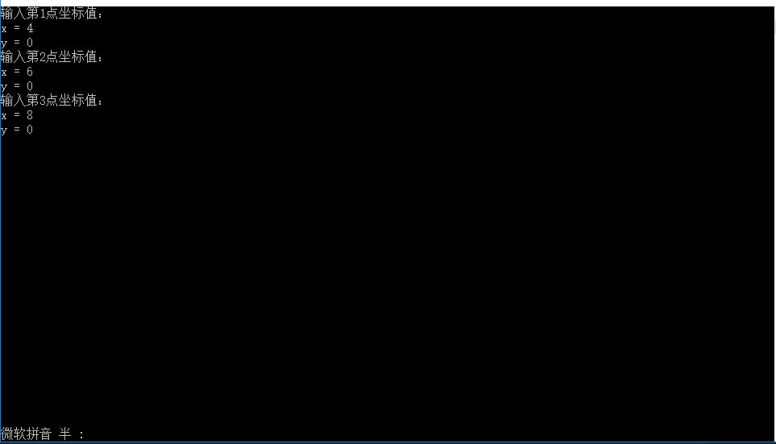

第六章 同步练习6.1-二-2

#include <iostream>

using namespace std;

class student

{

char name[20];

unsigned int id;

double score;

public:

void input()

{

cout<<"name? ";

cin>>name;

cout<<"id?";

cin>>id;

cout<<"score? ";

cin>>score;

}

void output()

{

cout<<"name: "<<name<<"\tid: "<<id<<"\tscore: "<<score<<endl;

}

};

int main()

{

student s;

s.input();

s.output();

}

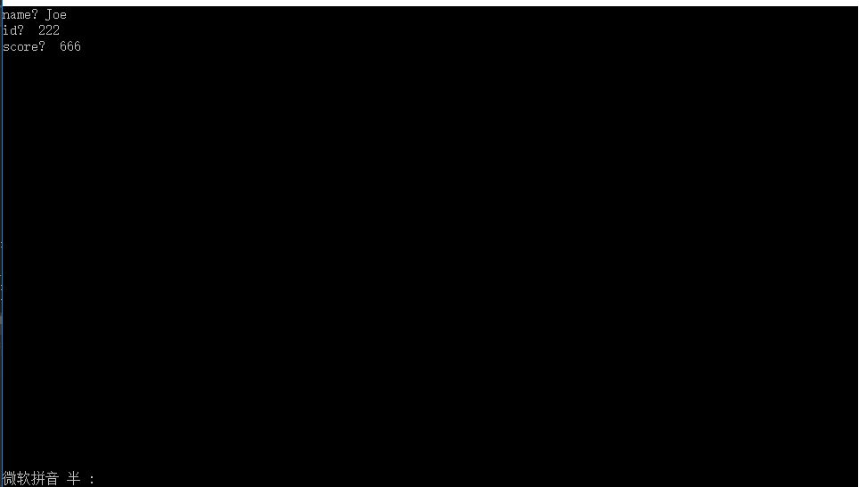

第六章 综合练习 二-1

#include <iostream>

using namespace std;

class Book

{

public:

void setBook(char*,double,int);

void borrow();

void restore();

void display();

private:

char bookname[40];

double price;

int number;

};

void Book::setBook(char *name, double pri, int num)

{

strcpy_s(bookname, name);

price=pri;

number=num;

}

void Book::borrow()

{

if (number==0 )

{

cout << "已没存书，退出！" << endl;

abort();

}

number = number - 1;

cout << "借一次，现存书量为：" << number << endl;

}

void Book::restore()

{

number = number + 1;

cout << "还一次，现存书量为：" << number << endl;

}

void Book::display()

{

cout << "存书情况：" << endl

<< "bookname:" << bookname << endl

<< "price:" << price << endl

<< "number:" << number << endl;

}

int main()

{

char flag, ch;

Book computer;

computer.setBook( "人间失格" , 39, 00 );

computer.display();

ch = 'y';

while ( ch == 'y' )

{

cout << "请输入借阅或归还标志(b/r)：";

cin >> flag;

switch ( flag )

{

case 'b': computer.borrow(); break;

case 'r': computer.restore();

}

cout << "是否继续？(y/n)";

cin >> ch;

}

computer.display();

}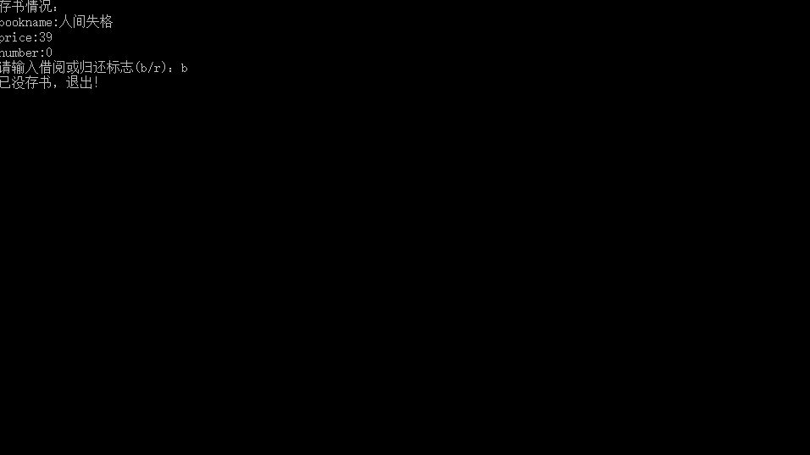

第六章 综合练习 二-3

#include <iostream>

using namespace std;

class student

{

public:

void scoretotalcount( double s )

{

score = s;

total = total + score;

count++;

}

static double sum()

{

return total;

}

static double average()

{

return total / count;

}

private:

double score;

static double total;

static double count;

};

double student::total=0;

double student::count=0;

int main()

{

int i,n; double s;

cout << "请输入学生人数：";

cin >> n;

student stu;

for( i=1; i<=n; i++ )

{

cout << "请输入第" << i << "个学生的分数：";

cin >> s;

stu.scoretotalcount( s );}

cout << "总分：" << student::sum() << endl;

cout << "平均分：" << student::average() << endl;

}

